*IEEE CS BDC Summer Symposium 2022,* IEEE Computer Society Bangladesh Chapter, 10-11 June, 2022

**Risk analysis and support system for children with**

**ASD using IoT**

**Shartaz Yeasar Feeham1, Susmita Debnath2, Tahiya Akter3 and Md. Solaiman Mia\***

Department of Computer Science and Engineering, Green University of Bangladesh

Email: 1mdfeeham@gmail.com, 2susmita.debnath.cse@gmail.com, 3stahiyaa@gmail.com and *solaiman@cse.green.edu.bd

**Extended Abstract:**

Autism Spectrum Disorder (ASD) is a medical condition which occurs mainly in children at the age of two to three. This disorder affects the communication and behaviour of a person. The autistic children have difficulty with communication, difficulty with social interactions, obsessive interests and repetitive behaviours as a result they face high risk of getting into critical situations if they are left alone free in the outside world. But they should not be encaged for that. Here we are about to build a system that uses Internet of Things or IoT devices such as sensors and monitoring displays for helping children with Autism Spectrum Disorder (ASD) to learn and improve their quality of life. The goal of our work is to analyse the efficient and suitable IoT components that can be used to design such a system that will be watching out what’s going around the ASD children all the time; by reading outer environment through sensors and analysing the readings using different limits and algorithms. Also, the system will be able to notify the guardians of the child if it finds any risk.

Autism Support System using RFID Technology [1] identifies the location of ASD child and informs parents using RFID. Though it used old but common and low costly technology beside all other available tools but it used backdated GSM, low range communication system. Also, it is not good with risk analysis or detecting critical situation. A support system for autistic children using Internet of Things technology [2] uses advanced computing device and multiple sensors to observe the children and acknowledge parents. It is pretty good with risk analysis but proposes a large, costly system, also there is a new feature called calming section is introduced but there is no proper technique for this is mentioned.

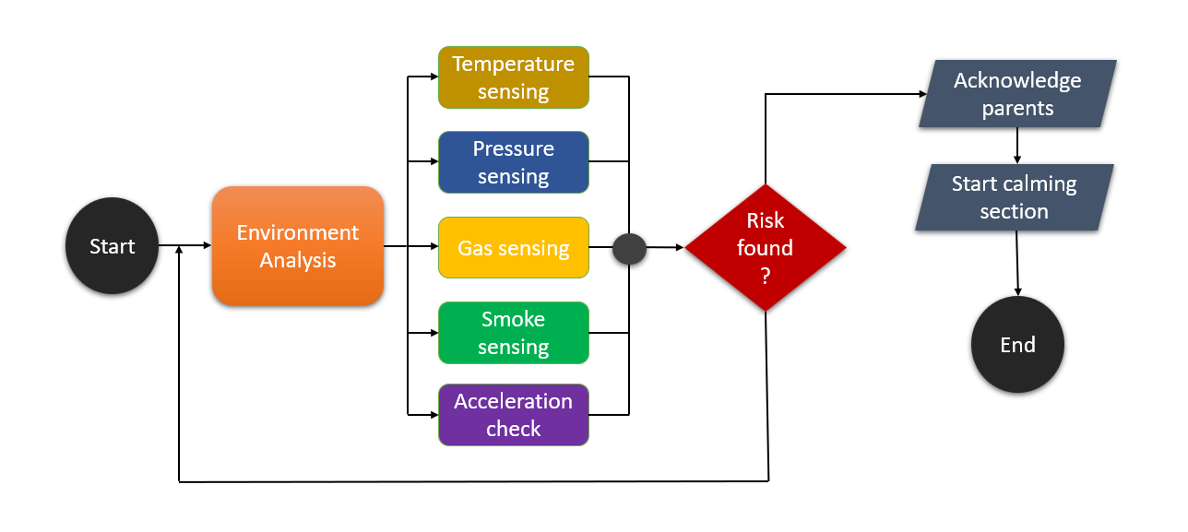

**Figure 1**: Flow chart of planned work

The benefits of our proposed work are as follows: consumers will be able to readily learn about almost all of Bangladesh's places as well as the traditional delicacies of various areas. This application can assist people in determining how much money they have to spend on a tour, discussing their tour experience after they have taken one, and more. Another factor to consider is that our application will be developed in both Bengali and English.

**References:**

|  |  |
| --- | --- |
| [1] | “Tourist Places or spot in Bangladesh,” *Tourist Places or Spot in Bangladesh | Places to Visit or Historical Places Bangladesh*, 02-Feb-2017. [Online]. Available: https://tourtoday.com.bd/. [Accessed: 24-May-2022]. |
| [2] | “Bangladesh travel guide,” *Google.com*. [Online]. Available: https://play.google.com/store/apps/details?id=com.beautifullbangladesh.bangladesh_bromon. [Accessed: 25-May-2022]. |